**Lab: Configuring ELB in Route53**

**Services Used: ELB & Route 53**

**Prerequisite:** Verify ELB status and should see the configured instances load balancing. If no load balancer configured, configure it first before proceeding with this Lab.

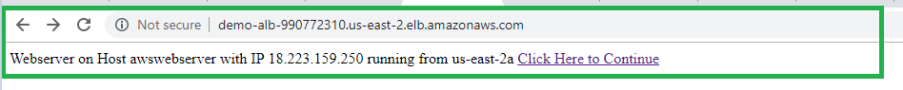

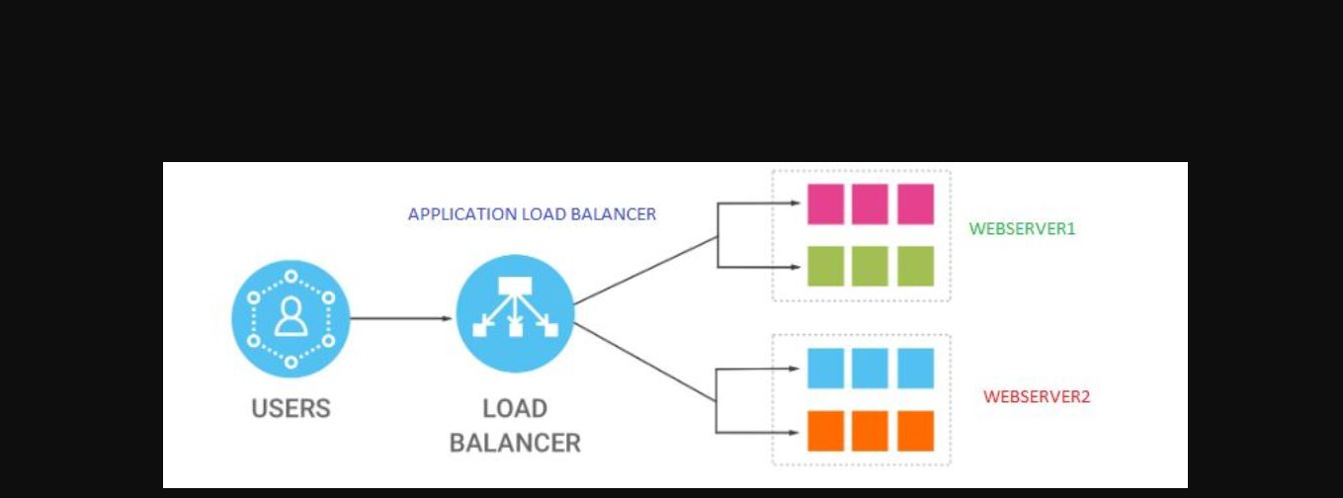

**Steps to Configure ELB in Route 53.**

1. Go to Route 53 Service
2. Select Hosted Zones and click on the domain name.

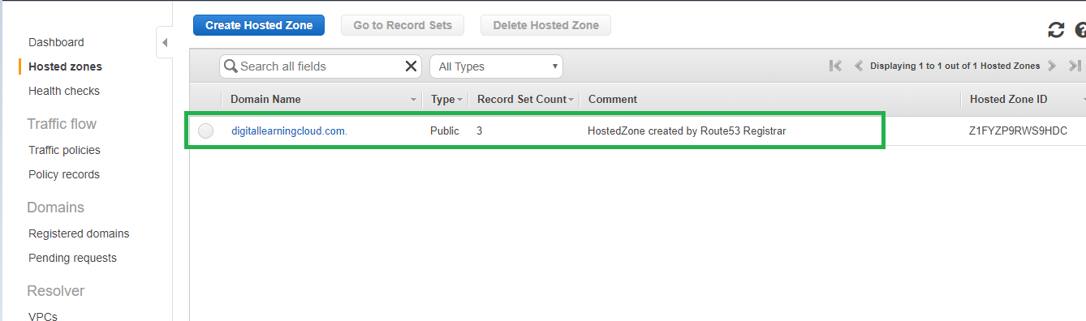

1. Inside the Domain, create a record set.

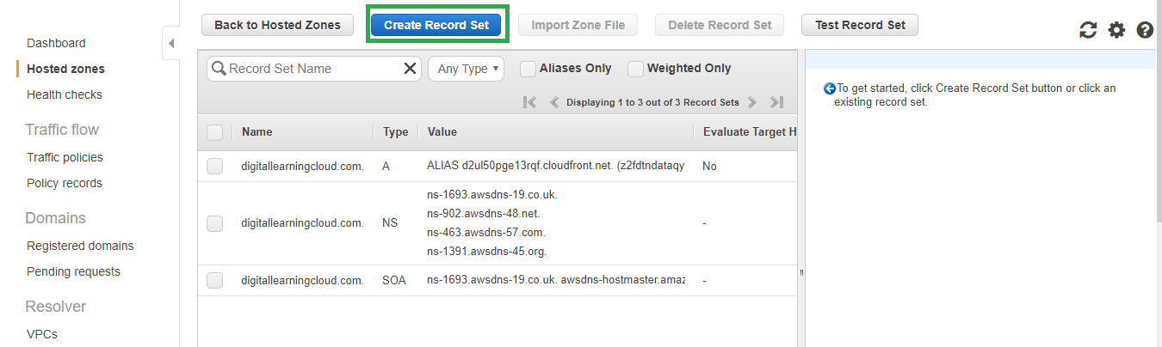

1. In the Record set field provide the Name as per your requirement and click Alias and Select the configured load balancer from the drop down list.

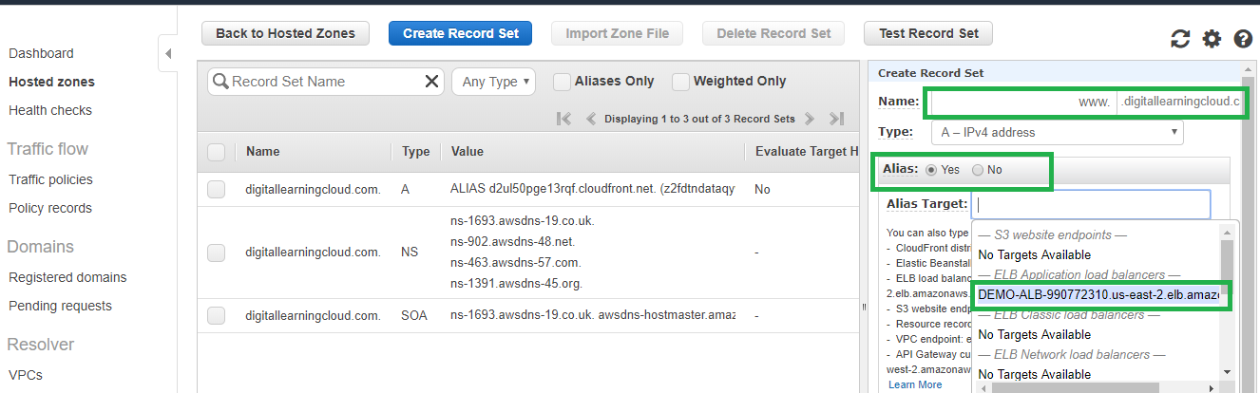

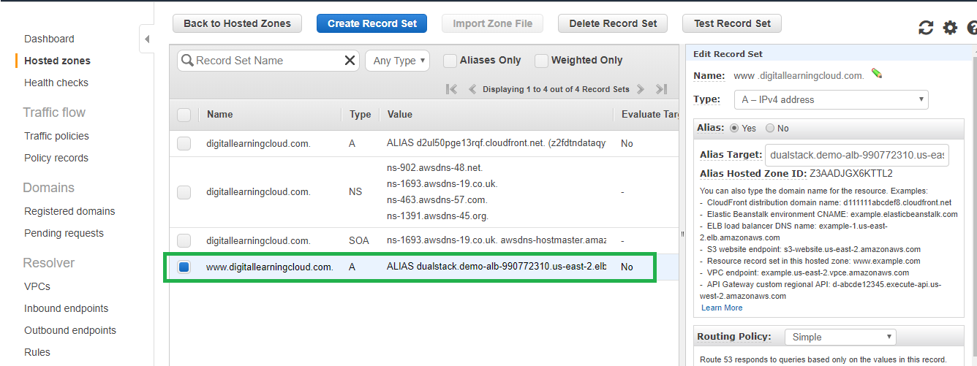

1. Verify now the domain is pointing to the Load Balancer.

